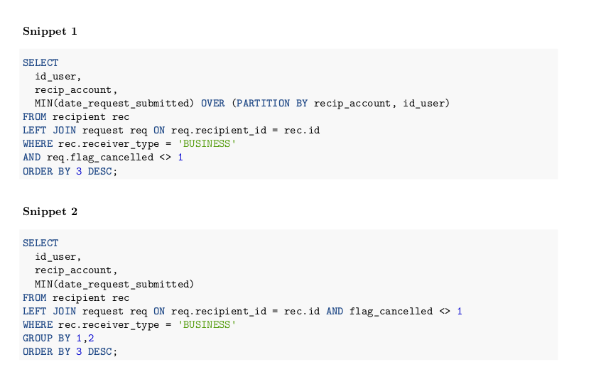
Expected Results:

Snippet 1 : summarize on all the (id_user, recip_account) and return all the records.
Snippet 2 : summarize on all the (id_user, recip_account) but only return summarized results.

Computational Complexity:

Although both queries may give the desired result, but Group by is not the optimal solution. We see that there is a JOIN statement and a sub-query. This increases the complexity of the query leading to a solution that is not efficient.

The better approach is in the snippet 1 through the use of OVER and PARTITION BY clauses

